COLLEGE OF COMPUTER STUDIES AND MULTIMEDIA ARTS

CS0065
(INTELLIGENT SYSTEMS)

TECHNICAL ASSESSMENT
2

RULE – BASED AGENT

Student Name | Ibasco, Ezekiel M.
Section: | AN42
Professor: | Ms. Crisola Tan
Date: | October 14, 2026

- BACKGROUND INFORMATION
A Rule-Based Agent is a type of intelligent agent that operates by following predefined rules to decide its actions. In this lab, students will work with a vacuum cleaner agent that can clean rooms or move between rooms depending on their state (dirty or clean).
The goal is to understand how agents perceive the environment, act according to rules, and update the environment.
- TECHNICAL ASSESSMENT

RULE – BASED AGENT

Objective

At the end of this laboratory activity, students are expected to:
- Explain the concept of rule-based agents.
- Implement a rule-based agent in Python.
- Interact with an environment by perceiving and acting based on rules.
- Observe and analyze the behavior of an agent in a controlled environment.
Materials Needed
- Computer with Python 3.x installed
- Text editor or IDE (e.g., VSCode, PyCharm)
- Optional: Jupyter Notebook for interactive testing

General Instructions
- This Technical Assessment (TA4) must be completed individually.
- Follow the Task below.
- Include clear comments in your code to describe its logic.
- Each program should display the correct input, process, and output.
- Ensure that your script displays clear and readable outputs.
- Compile all Python codes and corresponding outputs into one PDF file.
- Save it as TA2_lastname.pdf
(Example: TA2_Patilano.pdf)
- Submit the python file and PDF file.

Laboratory Task
Pre-Lab Preparation
- Review the Python concepts:
  - Classes and objects
  - If-Else statements
  - Loops (for loop)
  - Functions / methods
- Understand the environment:
  - Two rooms: A and B
  - Each room can be Dirty or Clean

Task 1: Set Up the Environment
- Initialize two rooms using a Python dictionary.
- Allow the user to set the initial state of each room (dirty or clean).
- Write a function to check if a room is dirty and a function to clean a room.
Sample Output
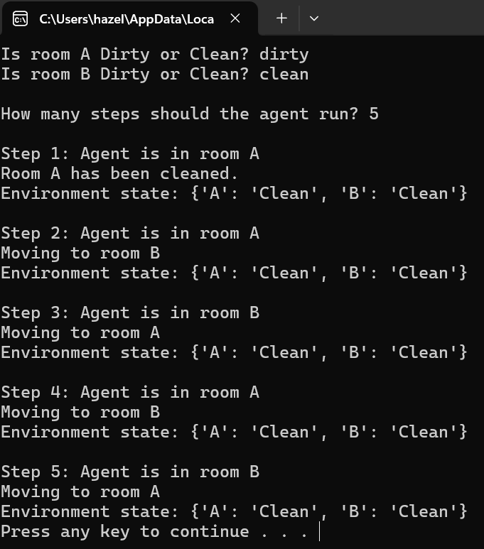

Task 2: Implement the Rule-Based Agent
- Create a class for the agent.
- Implement the perceive-and-act method:
  - Rule 1: If the current room is dirty, clean it.
  - Rule 2: If the current room is clean, move to the other room.
- Implement a move method to switch rooms.
Task 3: Run the Simulation
- Ask the user how many steps the simulation should run.
- Run the agent in a loop for the specified steps.
- After each step, print:
  - The agent’s current location
  - The action taken (cleaned/moved)
  - Current state of the environment

Optional (Bonus Task)

- Add a third room (C) and update the agent logic.
- Make the agent randomly choose which dirty room to clean next.
- Visualize the agent moving between rooms using a text-based grid.
Sample Output (Bonus Task)
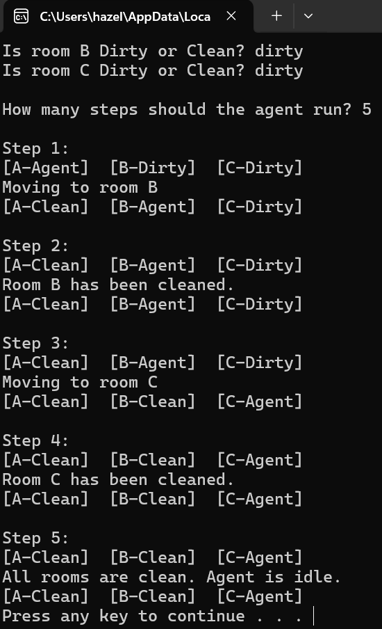

Your Code - Laboratory Tasks

Task 4: Analysis Questions
After running the simulation, answer the following:
- What rules does the agent follow?
- How does the agent decide when to clean and when to move?
- What happens if both rooms are already clean at the start?
- How would you modify the agent to handle more than two rooms?

Answer the Questions

